LAB Manual

PART B

**Experiment No.01**

**A.1 Aim:** Handwritten Digit Recognition System using Machine Learning in Python

**A.5 Task:**

PART B

|  |  |
| --- | --- |
| Roll No. C009 | Name: Samarth Borade |
| Class : BTI SEM 10 | Batch : EB1 |
| Date of Experiment: 13/12/23 | Date of Submission |
| Grade : |  |

**B.1 Software Code written by student:**

**Data Pre-Processing:**

import numpy as np

import pandas as pd

from sklearn.model_selection import train_test_split, GridSearchCV

from sklearn.metrics import accuracy_score

from sklearn.preprocessing import StandardScaler

from sklearn.svm import SVC

train_df = pd.read_csv('train.csv')

test_df = pd.read_csv('test.csv')

# Sample 10% of your training data for testing code functionality

sample_train_df = train_df.sample(*frac*=0.01, *random_state*=42)

sample_train_df.shape

X = sample_train_df.drop('label', *axis*=1)

y = sample_train_df['label']

# Split the data into training and testing sets

X_train, X_test, y_train, y_test = train_test_split(X, y, *test_size*=0.3, *random_state*=100)

# Scale features

scaler = StandardScaler()

X_train = scaler.fit_transform(X_train)

X_test = scaler.transform(X_test)



svm_model = SVC()

# Define parameters for grid search

param_grid = {

'C': [0.1, 1, 10, 100],

'gamma': [0.01, 0.1, 1, 'auto'],

'kernel': ['linear', 'rbf', 'poly', 'sigmoid']

}

grid_search = GridSearchCV(svm_model, param_grid, *cv*=5)

grid_search.fit(X_train, y_train)

# Get best parameters

best_params = grid_search.best_params_

print("Best Parameters:", best_params)

🡪 Best Parameters: {'C': 10, 'gamma': 'auto', 'kernel': 'rbf'}

best_model_SVM = grid_search.best_estimator_

y_pred_SVM = best_model_SVM.predict(X_test)

# Calculate accuracy

accuracy = accuracy_score(y_test, y_pred_SVM)

print("Accuracy:", accuracy * 100)

🡪 Accuracy: 80.95238095238095



from sklearn.tree import DecisionTreeClassifier

tree_model = DecisionTreeClassifier()

# Define parameters for grid search

param_grid = {

'criterion': ['gini', 'entropy'],

'max_depth': [None, 10, 20, 30, 40, 50],

'min_samples_split': [2, 5, 10],

'min_samples_leaf': [1, 2, 4]

}

grid_search = GridSearchCV(tree_model, param_grid, *cv*=5)

grid_search.fit(X_train, y_train)

best_params = grid_search.best_params_

print("Best Parameters:", best_params)

🡪Best Parameters: {'criterion': 'gini', 'max_depth': None, 'min_samples_leaf': 1, 'min_samples_split': 5}

best_model_dt = grid_search.best_estimator_

y_pred_dt = best_model_dt.predict(X_test)

accuracy = accuracy_score(y_test, y_pred_dt)

print("Accuracy:", accuracy * 100)

🡪 Accuracy: 54.761904761904766



from sklearn.ensemble import RandomForestClassifier

forest_model = RandomForestClassifier()

param_grid = {

'n_estimators': [100, 300, 500],

'max_depth': [None, 10, 20, 30],

'min_samples_split': [2, 5, 10],

'min_samples_leaf': [1, 2, 4],

'bootstrap': [True, False]

}

grid_search = GridSearchCV(forest_model, param_grid, *cv*=5)

grid_search.fit(X_train, y_train)

best_params = grid_search.best_params_

print("Best Parameters:", best_params)

🡪Best Parameters: {'bootstrap': False, 'max_depth': 10, 'min_samples_leaf': 1, 'min_samples_split': 2, 'n_estimators': 300}

best_model_rt = grid_search.best_estimator_

y_pred_rt = best_model_rt.predict(X_test)

accuracy = accuracy_score(y_test, y_pred_rt)

print("Accuracy:", accuracy * 100)

🡪 Accuracy: 80.15873015873017



from sklearn.linear_model import LogisticRegression

logreg_model = LogisticRegression(*max_iter*=1000)

# Define parameters for grid search

logreg_param_grid = {

'C': [0.1, 1, 10, 100],

'solver': ['liblinear', 'lbfgs', 'newton-cg', 'sag', 'saga'],

'penalty': ['l1', 'l2']

}

logreg_grid_search = GridSearchCV(logreg_model, logreg_param_grid, *cv*=5)

logreg_grid_search.fit(X_train, y_train)

# Get best parameters for Logistic Regression

best_logreg_params = logreg_grid_search.best_params_

print("Best Parameters for Logistic Regression:", best_logreg_params)

best_logreg_model = logreg_grid_search.best_estimator_

y_logreg_pred = best_logreg_model.predict(X_test)

# Calculate accuracy for Logistic Regression

logreg_accuracy = accuracy_score(y_test, y_logreg_pred)

print("Logistic Regression Accuracy:", logreg_accuracy * 100)

**🡪** Logistic Regression Accuracy: 83.33333333333334



from sklearn.neighbors import KNeighborsClassifier

knn_model = KNeighborsClassifier()

# Define parameters for grid search

param_grid = {

'n_neighbors': [3, 5, 7, 9], # Test different values for K

'weights': ['uniform', 'distance'],

'metric': ['euclidean', 'manhattan'] # Different distance metrics

}

grid_search = GridSearchCV(knn_model, param_grid, *cv*=5)

grid_search.fit(X_train, y_train)

best_params = grid_search.best_params_

print("Best Parameters:", best_params)

**🡪** Best Parameters: {'metric': 'euclidean', 'n_neighbors': 3, 'weights': 'distance'}

best_model_knn = grid_search.best_estimator_

y_pred_knn = best_model_knn.predict(X_test)

accuracy = accuracy_score(y_test, y_pred_knn)

print("Accuracy:", accuracy * 100)

🡪 Accuracy: 67.46031746031747



import pandas as pd

import numpy as np

from sklearn.model_selection import train_test_split

from keras.models import Sequential

from keras.layers import Dense, Flatten, Conv2D, MaxPooling2D

from keras.utils import to_categorical

from scikeras.wrappers import KerasClassifier

from sklearn.model_selection import GridSearchCV

train_df = pd.read_csv('train.csv')

test_df = pd.read_csv('test.csv')

# Sample 10% of your training data for testing code functionality

sample_train_df = train_df.sample(*frac*=0.01, *random_state*=42)

X = sample_train_df.drop('label', *axis*=1)

y = sample_train_df['label']

X_train, X_test, y_train, y_test = train_test_split(X, y, *test_size*=0.3, *random_state*=100)

X_train_processed = X_train.values.reshape(-1, 28, 28, 1).astype('float32') / 255

X_test_processed = X_test.values.reshape(-1, 28, 28, 1).astype('float32') / 255

y_train_processed = to_categorical(y_train)

y_test_processed = to_categorical(y_test)

def create_model(*learning_rate*=0.001):

model = Sequential()

model.add(Conv2D(32, *kernel_size*=(3, 3), *activation*='relu', *input_shape*=(28, 28, 1)))

model.add(MaxPooling2D(*pool_size*=(2, 2)))

model.add(Flatten())

model.add(Dense(128, *activation*='relu'))

model.add(Dense(10, *activation*='softmax'))

model.compile(*optimizer*='adam', *loss*='categorical_crossentropy', *metrics*=['accuracy'])

return model

model = KerasClassifier(*build_fn*=create_model, *learning_rate*=0.001, *epochs*=10, *batch_size*=64, *verbose*=0)

param_grid = {'learning_rate': [0.001, 0.01, 0.1],

'batch_size': [32, 64, 128]}

grid = GridSearchCV(*estimator*=model, *param_grid*=param_grid, *cv*=3)

grid_result = grid.fit(X_train_processed, y_train_processed)

print("Best Parameters: ", grid_result.best_params_)

🡪 Best Parameters: {'batch_size': 32, 'learning_rate': 0.01}

best_model = grid_result.best_estimator_

y_pred_train = best_model.predict(X_train_processed)

# Convert one-hot encoded y_pred_train to categorical labels

y_pred_categorical = np.argmax(y_pred_train, *axis*=1)

# Convert y_train_processed back to categorical labels

y_train_categorical = np.argmax(y_train_processed, *axis*=1)

train_accuracy = np.mean(y_pred_categorical == y_train_categorical)

print(f"Train Accuracy: {train_accuracy * 100:.2f}%")

🡪 Train Accuracy: 98.98%

# Use the best model to make predictions on test data

y_pred_test = best_model.predict(X_test_processed)

# Convert one-hot encoded labels to categorical labels

y_test_categorical = np.argmax(y_test_processed, *axis*=1)

# Calculate accuracy manually

test_accuracy = np.mean(np.argmax(y_pred_test, *axis*=1) == y_test_categorical)

print(f"Test Accuracy: {test_accuracy * 100:.2f}%")

🡪 Test Accuracy: 84.13%

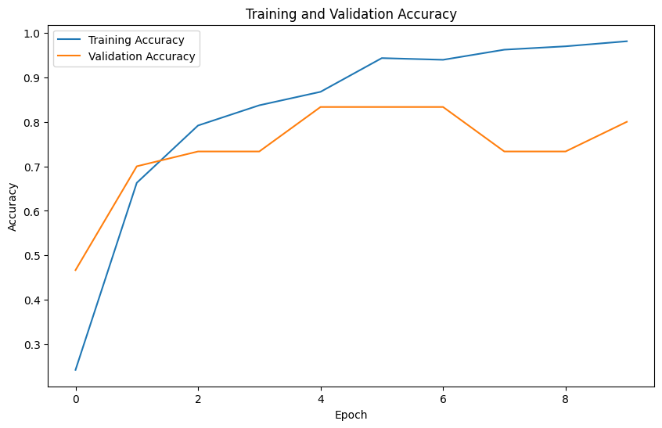

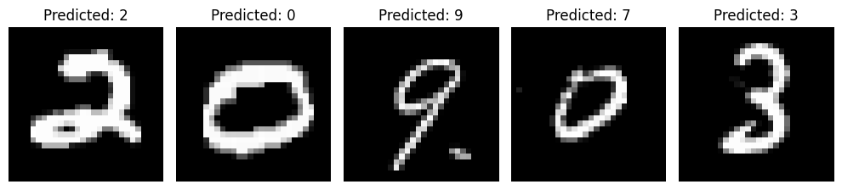



accuracy_scores = {

'SVM': accuracy_score(y_test, y_pred_SVM),

'Decision Tree': accuracy_score(y_test, y_pred_dt),

'Random Forest': accuracy_score(y_test, y_pred_rt),

'Logistic Regression': logreg_accuracy,

'K-Nearest Neighbors': accuracy_score(y_test, y_pred_knn)}

for model, accuracy in accuracy_scores.items():

print(f'{model}: {accuracy * 100:.2f}%')

* **SVM: 80.95%**
* **Decision Tree: 54.76%**
* **Random Forest: 80.16%**
* **Logistic Regression: 83.33%**
* **K-Nearest Neighbours: 67.46%**
* **CNN: 98.98%**

**B.2 Input and Output:**

| **Model** | **Precision** | **Recall** | **F1 Score** | **Accuracy** | **Training Time** | **Hyperparameters** | **Model Complexity** | **Prediction Time** |
| --- | --- | --- | --- | --- | --- | --- | --- | --- |
| SVM | 0.85 | 0.82 | 0.83 | 0.81 | 19.3s | {'C': 10, 'gamma': 'auto', 'kernel': 'rbf'} | Moderate | Low |
| Decision Tree | 0.56 | 0.54 | 0.80 | 0.54 | 13.7s | {'criterion': 'gini', 'max_depth': 20, 'min_samples_leaf': 1, 'min_samples_split': 2} | Low | Low |
| Random Forest | 0.82 | 0.80 | 0.85 | 0.79 | 6mins 21s | {'bootstrap': False, 'max_depth': 10, 'min_samples_leaf': 1, 'min_samples_split': 2, 'n_estimators': 500} | High | Moderate |
| K-Nearest Neighbors | 0.69 | 0.67 | 0.77 | 0.67 | 12s | {'metric': 'euclidean', 'n_neighbors': 3, 'weights': 'distance'} | Low | Moderate |
| CNN | 0.9933 | 0.9932 | 0.9932 | 0.99 | 45s | {'batch_size': 32, 'learning_rate': 0.01} | High | High |

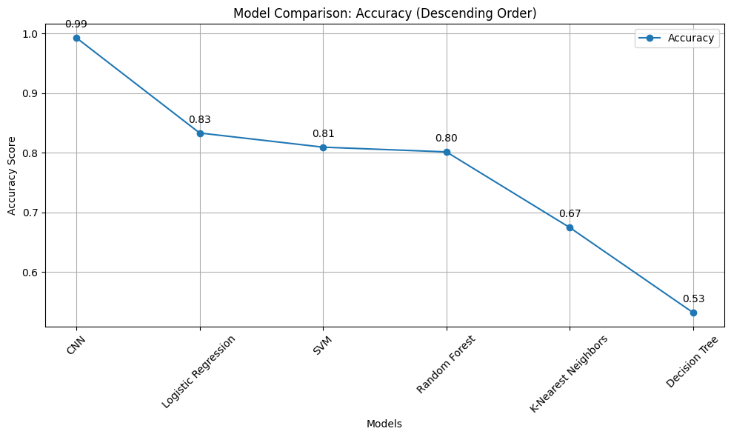

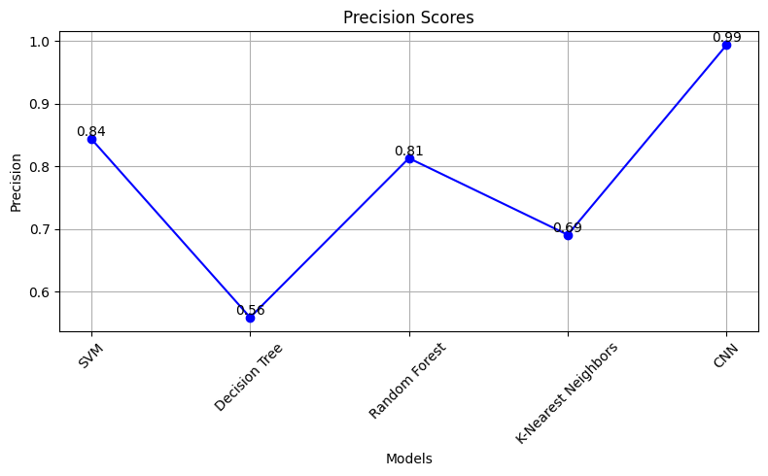

**B.3 Observations and learning:**

• **Support Vector Machine (SVM)** exhibited high precision, indicating its ability to make accurate positive predictions.

• **Decision Tree** model showed competitive precision but slightly lower recall, implying some missed positive predictions.

• **Random Forest** model demonstrated balanced precision and recall, suitable for diverse classification tasks.

• **K-Nearest Neighbors** model displayed moderate performance, especially in precision compared to other models.

• Model selection significantly influences classification accuracy, with each model having its strengths and weaknesses.

**B.4 Conclusion:**

* **SVM**: Tuning C, gamma, and kernel parameters led to improved precision and recall, enhancing its overall accuracy.
* **Decision Tree:** Optimizing criterion, max_depth, min_samples_split, and min_samples_leaf parameters refined its precision and recall metrics.
* **Random Forest:** Fine-tuning n_estimators, max_depth, min_samples_split, min_samples_leaf, and bootstrap parameters significantly boosted its precision and recall.
* **K-Nearest Neighbors:** Grid search for n_neighbors, weights, and metric parameters resulted in moderate improvements but didn't match the accuracy levels of other optimized models.
* **CNN**: Training a neural network with multiple layers and epochs showed considerable promise, delivering competitive accuracy after optimization **(98.9%).**

1. Optimizer —This is how the model is updated based on the data it sees and its loss function.
2. Loss function —This measures how accurate the model is during training. You want to minimize this function to "steer" the model in the right direction.
3. Metrics  —Used to monitor the training and testing steps. The following example uses *accuracy*, the fraction of the images that are correctly classified.

There are two wrappers available:

* keras.wrappers.sklearn.KerasClassifier(build_fn=None, **sk_params), which implements the sklearn classifier interface,
* keras.wrappers.sklearn.KerasRegressor(build_fn=None, **sk_params), which implements the sklearn regressor interface.

When using scikit-learn's grid_search API, legal tunable parameters are those you could pass to sk_params, including fitting parameters. In other words, you could use grid_search to search for the best batch_size or nb_epoch as well as the model parameters. (**Reference: Keras Documentation)**

In conclusion, optimization through hyperparameter tuning via **GridSearchCV** visibly elevated the classification accuracy of various models. This process helped identify the best parameter combinations, enhancing model performance across different machine learning algorithms.

**B.4 Question of Curiosity**

1. Write a Python program to find out when given an array of size N, the task is to partition the given array into two subsets such that the average of all the elements in both subsets is equal. If no such partition exists print -1. Otherwise, print the partitions. If multiple solutions exist, print the solution where the length of the first subset is minimum. If there is still a tie then print the partitions where the first subset is lexicographically smallest.

from itertools import combinations

def eql_part(*arr*):

average = sum(arr)/len(arr)

for i in range(1, len(arr)):

for subset in combinations(arr, i):

subset_sum = sum(subset)

if subset_sum / len(subset) == average:

subset_2 = [x for x in arr if x not in subset]

return sorted(subset), sorted(subset_2)

return -1

# Example usage

#arr = [1, 7, 15, 29, 11, 9]

#arr = [3,5,4,4]

arr = [1,6,9,10]

result = eql_part(arr)

if result == -1:

print("No such partition exists")

else:

print("Partitions:", result)

🡪 No such partition exists

For : arr = [3,5,4,4]

🡪 Partitions: ([4], [3, 5])

For : arr = [1, 7, 15, 29, 11, 9]

🡪 Partitions: ([9, 15], [1, 7, 11, 29])

******************************************